What the World Needs Now is

Authenticity
Authenticity
Authenticity

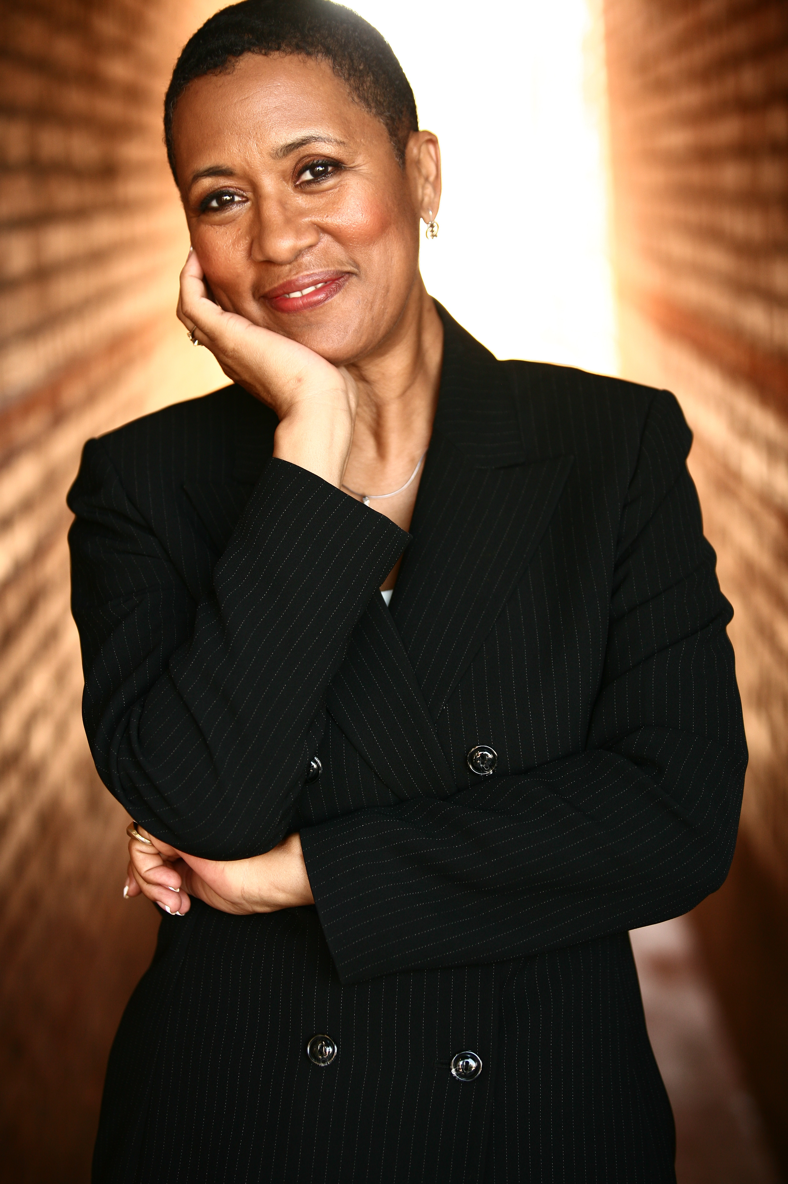

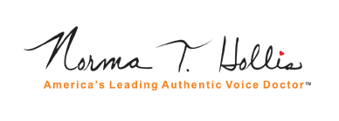

The Case for Authenticity
What is Authenticity?

- Establishing authority for truth and correctness
- Genuineness; the quality of being genuine, not corrupted
- True to one’s own personality, spirit or character
- Neither false nor imitation; real, actual
- Sincerity applied to the common good
- Aligning common good values with societal economic, ecological and human sustainability needs.

- Plastic surgery for youth under age 18 increases by 375% between 1997 and 2003.
- FDA approves the sale of meat from cloned beef without requiring labeling to identify it as artificial,
- Three auto industry CEO’s take separate private jets to ask the government for money to bail out their failing corporations,
- A United States Governor tries to sell a Senate seat,
- On Christmas Day 2008 the Pope suggests we gain a "spirit of authentic solidarity" to stop global ruin because if people look only to their own interests our world will certainly fall apart,

These are a few of the rampant incidences of inauthentic activity taking place in our world. Yet there is a growing trend that “authenticity matters” - in our homes, our families, our places of work, our political, educational and religious institutions.

Enter America’s Leading Authentic Voice Doctor®

Authenticity expert Norma T. Hollis has researched authenticity for over 30 years. She has also spent 13 years in the professional speaking industry as a coach, trainer and speaker bureau owner. By combining her authenticity research with communication concepts she has gained a deep understanding of how important it is for individuals and corporations to find, live and share their authenticity which she refers to as their “authentic voice”. She has uncovered the nine dimensions of authenticity that apply to both individuals and corporations and challenges both to examine the “voice” they are sharing with the world. For individuals this means connecting with their authentic path in life that leads to sustainable joy. For corporations this means improving the triple bottom line—economic, environmental and social. For both it means clarity, improved judgment, hope, joy, maximized productivity and enhancing the common good.

Norma’s presentations educate, empower and inspire. Grounded in the three domains and nine dimensions of authenticity, (see last page) Norma helps audiences examine what authenticity means to them and how to apply authenticity concepts to their everyday lives.

Signature photo goes here

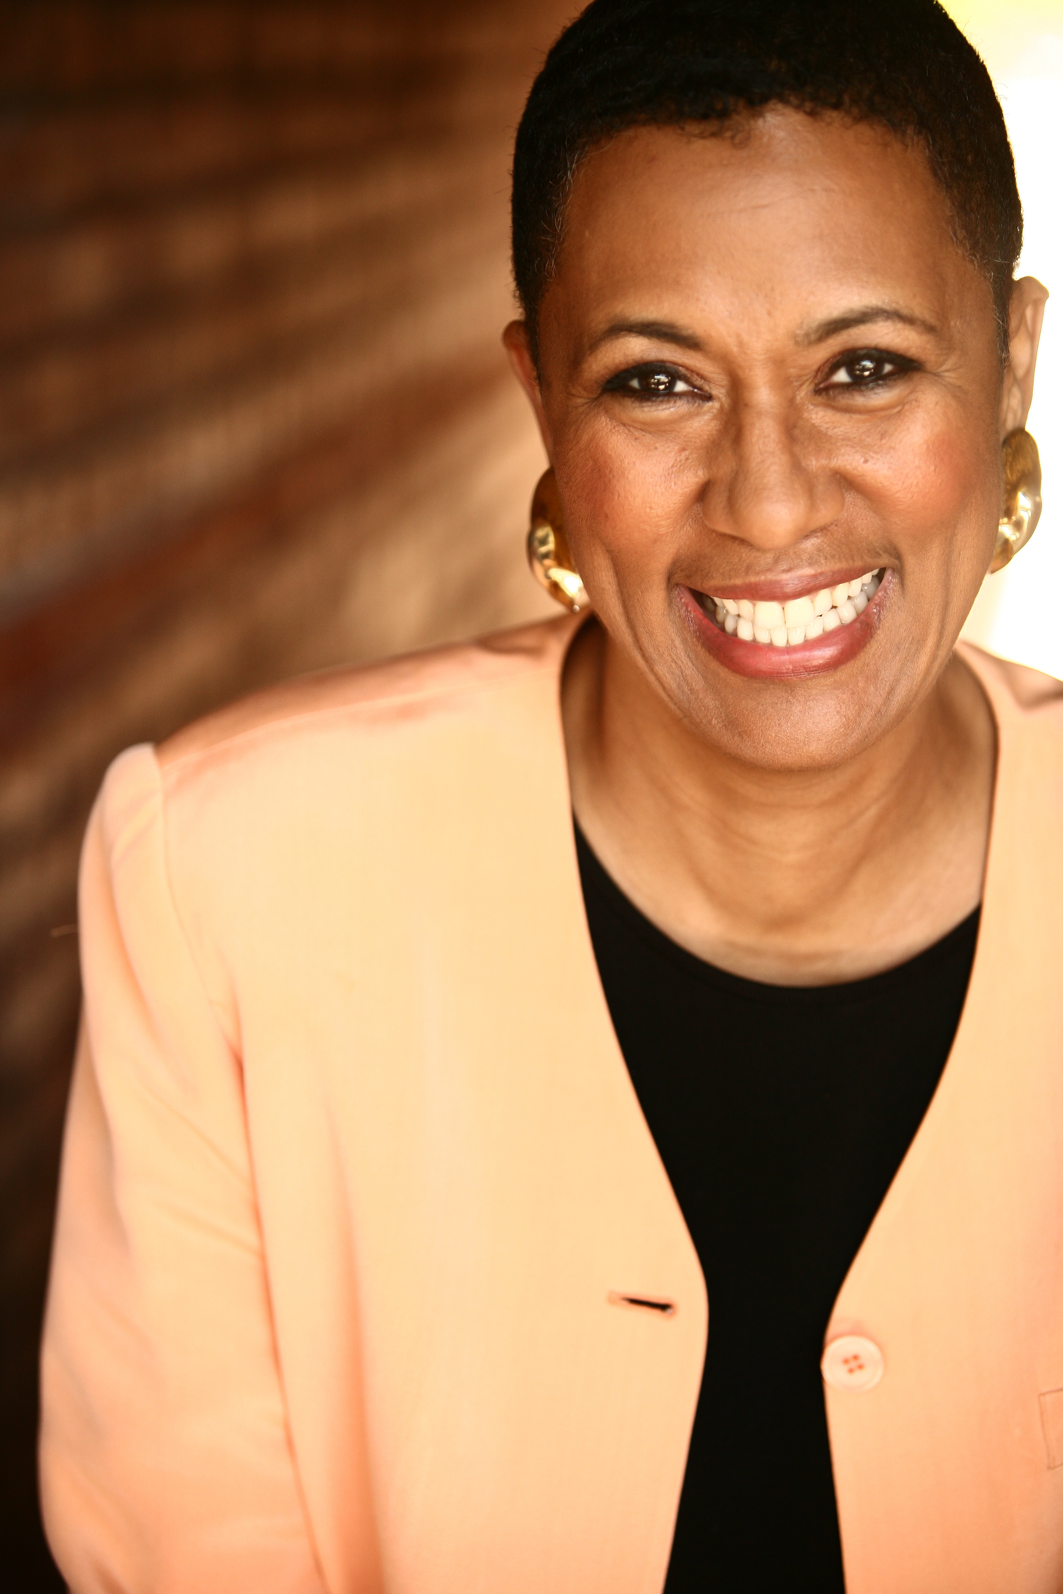

Norma T. Hollis is a charismatic communicator. Her dynamic presentations challenge traditional thinking and open up a deeper understanding of the need for authenticity. Audiences emerge with broader authenticity perspectives. Inspired to achieve more, they can reach for their full potential and remain motivated to improve the quality of their lives. Organizations emerge with a renewed spirit and commitment to authenticity within their organizations. Norma possesses a rare ability to connect people and organizations with their purpose and delights audiences with her charming personality, depth of knowledge and strength of spirit.

PROGRAMS
Customized
Keynotes * Seminars * Training Processes

What the World Needs Now—Authenticity
In today’s climate of falling economies, endangered ecologies and unregulated human greed and need, it is time to establish authority for truth and correctness and enhance a genuine and sincere focus on the common good. Norma’s signature presentation introduces the dimensions of authenticity and connects them to the issues of the organization to promote a culture of authenticity that aligns economic, ecological and human needs.
- Ten Steps to Authenticity—Take the Authenticity Assessment, get your authenticity score and learn the importance of vertical and horizontal alignment for individuals and organizations.
- Live Your Authentic Life—Inspirational message where Norma shares her personal journey to authenticity and inspires audiences to live their authentic life.
- Authentic Career Paths—Learn to leverage your gifts and talents and other dimensions of authenticity to find, live and enjoy your authentic career.
- Join the Authenticity Movement—Learn about the Authenticity Movement and how to join the hundreds of individuals who are turning the concept of authenticity into a world-wide movement.

Leadership Authenticity
Authentic organizations have a culture of authenticity that is demonstrated by leadership and emulated by team members. Leadership authenticity means alignment with team members based on their gifts and talents, the need for emerging leadership and authentic leadership sustainability. Authentic leaders start the authenticity process. Cultures of authenticity keep the process growing.
- Building Authentic Teams—Applies the nine dimensions of authenticity to team building.
- Authentic Corporate Leadership—Explores how corporations can lead the authenticity movement within their industry/region/nation.
- The Authentic Leader—Authenticity concepts applied to the development of current and emerging leaders.
- Authentic Inclusion—Applies authenticity concepts to diversity issues.

Authentic Communication
As a trainer of professional speakers and previous owner of a speakers bureau, Norma is an expert communicator. She believes that the best communicators are those who speak from their heart and share an authentic message. She assists individuals and companies to improve communication within themselves, with co-workers, the general public and in sales presentations.
- Speak With Ease and Confidence—Basic communication tips and coaching to improve public speaking skills.
- Become a Professional Speaker—Assists those aspiring to become professional speakers to understand the process and industry of professional speaking.
- Gender Communication—Improves communication between males and females within work groups.
- Multi-Ethnic Communication—Designed for workgroups comprised of numerous ethnic backgrounds. Assists participants to retain their authenticity while improving communication with those of other cultures.
- Authentic Communication Wins Customers—Assists sales and customer service teams to improve communication in the marketplace.

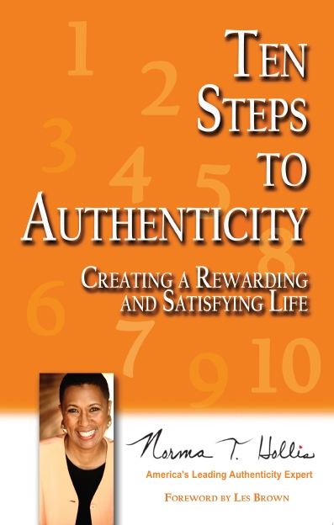

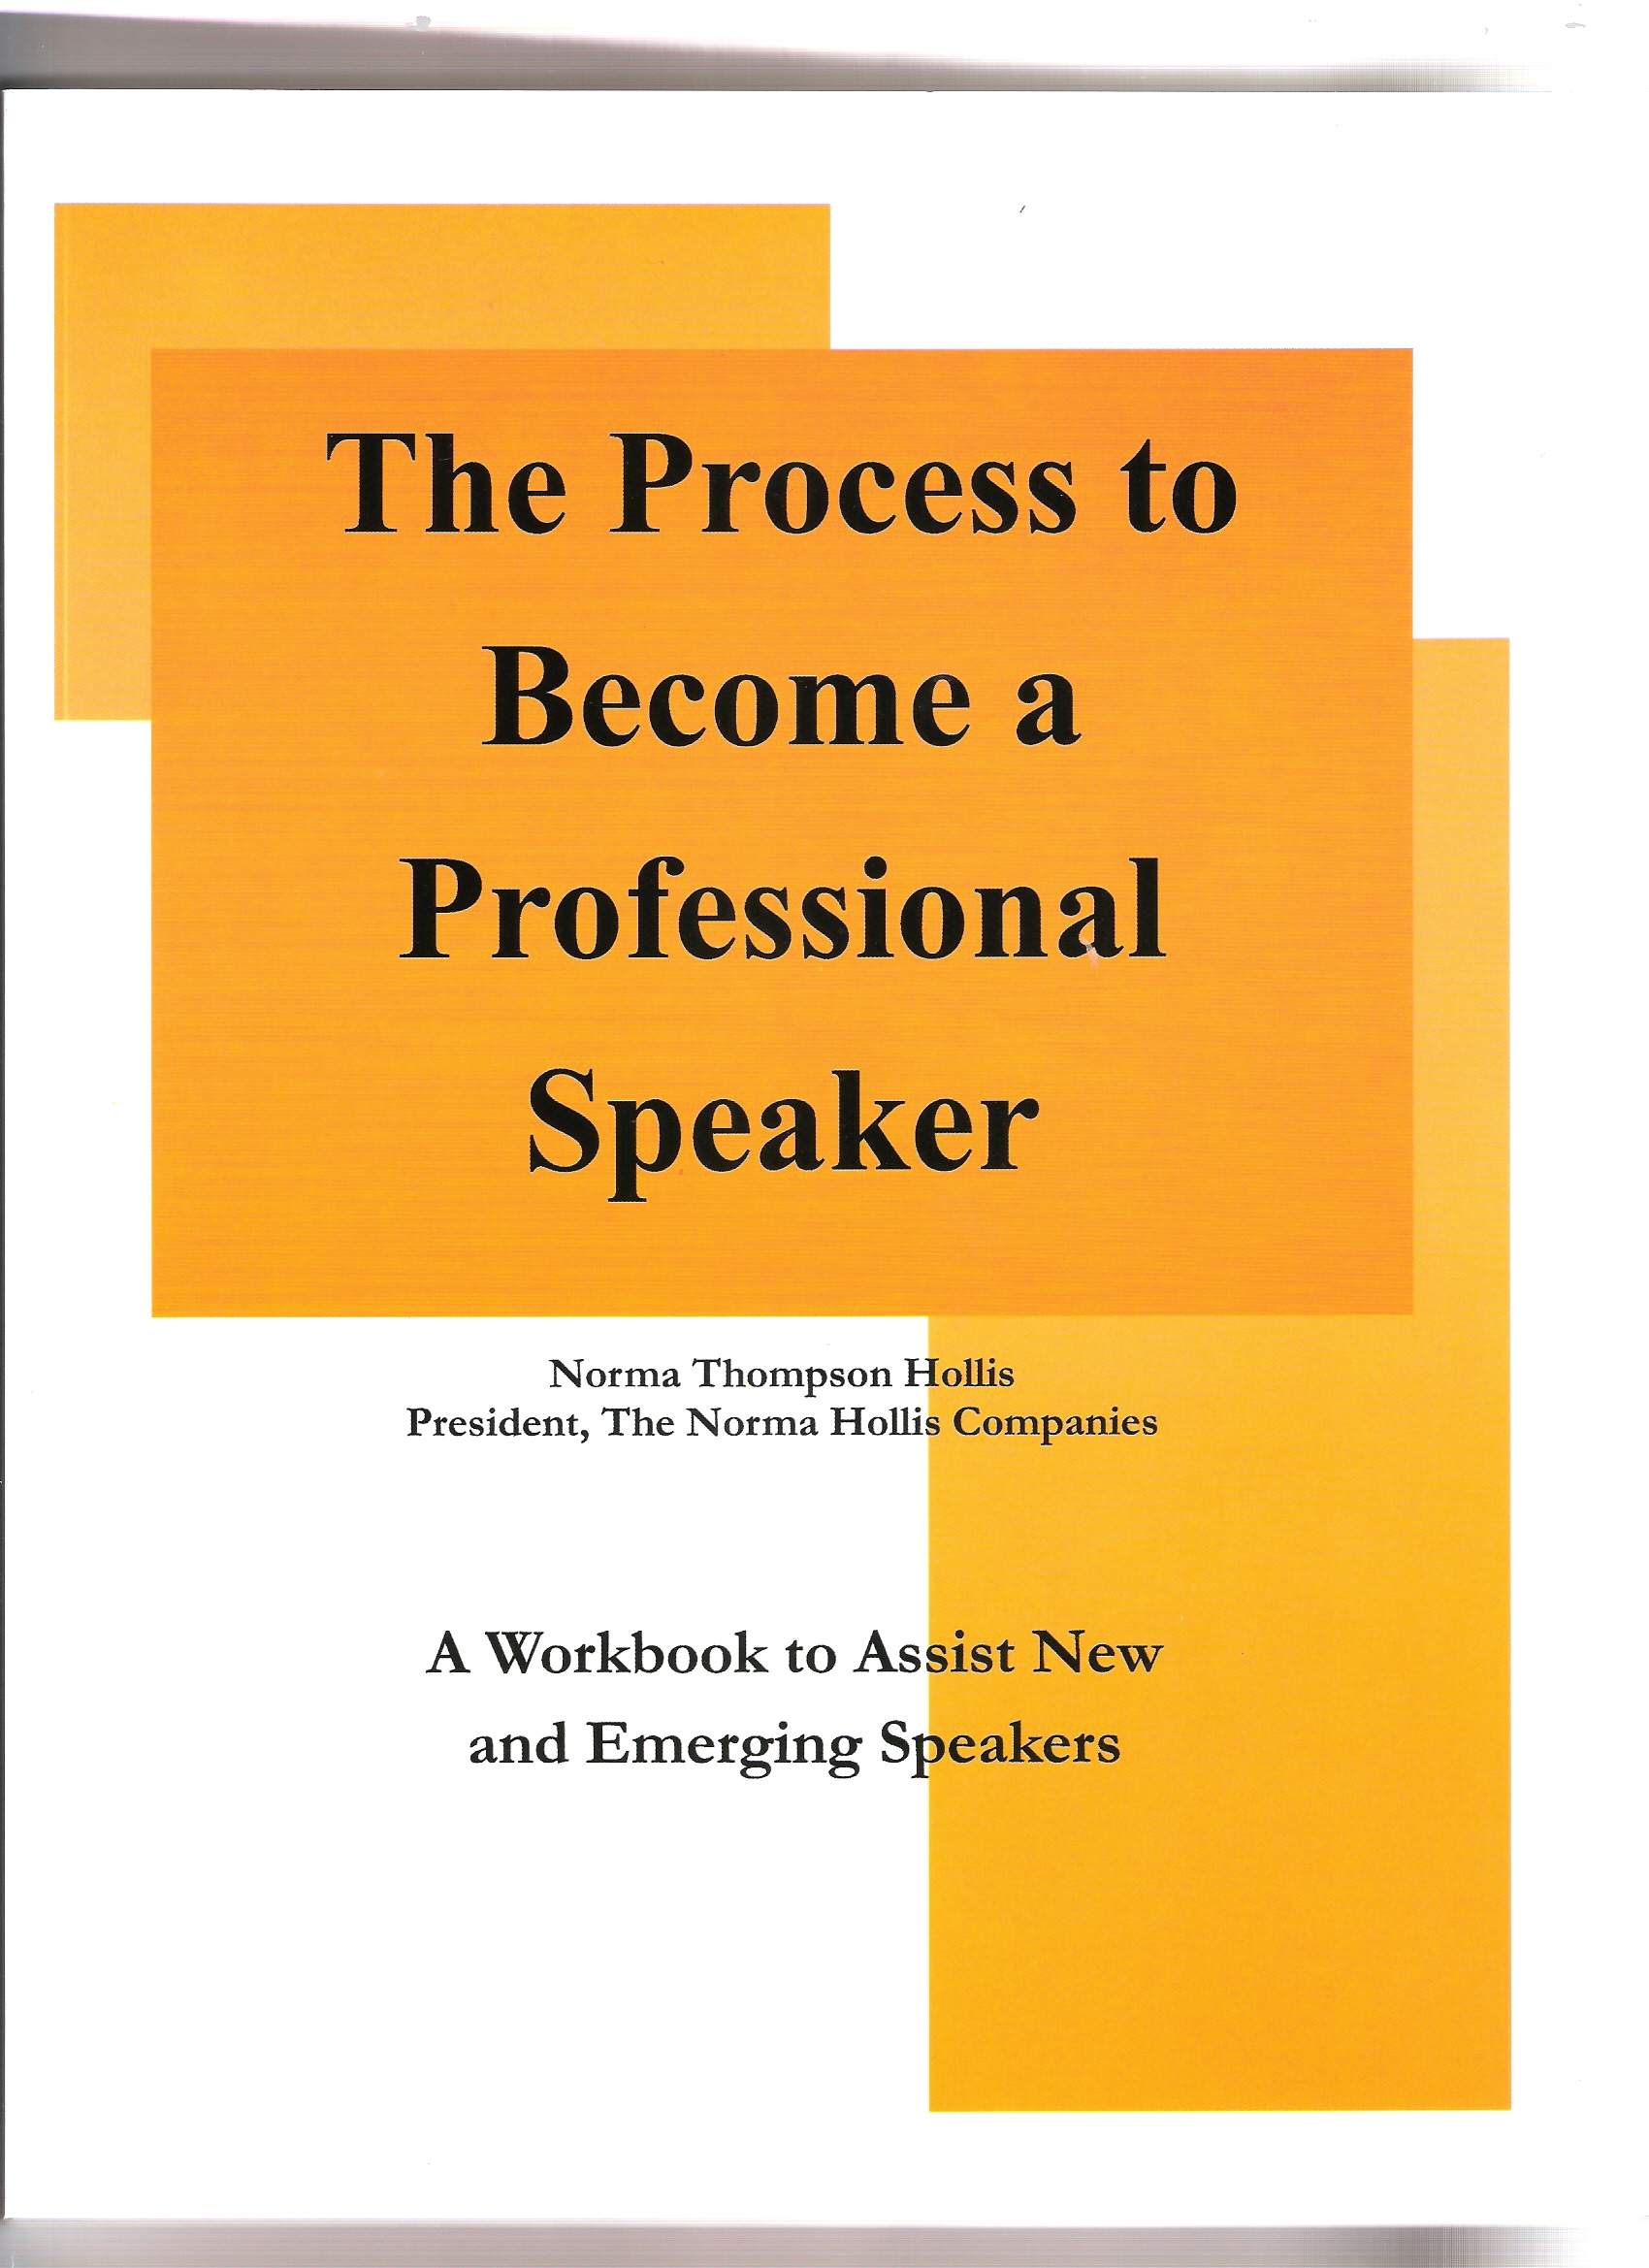

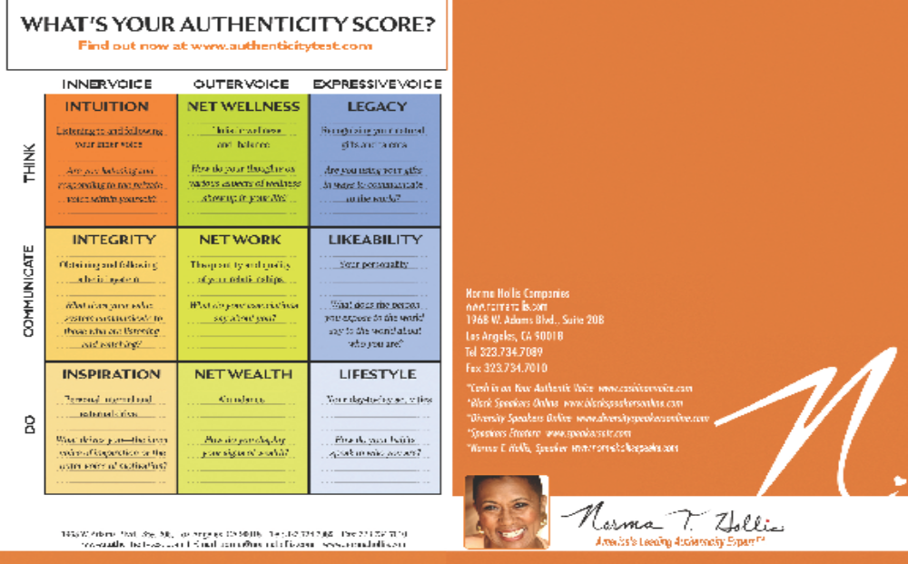
Testimonials
Partial Client List

Blue Cross
California State University
Charles R. Drew University
Children’s Defense Fund
City of Beverly Hills
City of Long Beach
Compton College
El Camino College
Fayetteville State University
Hillside Family of Agencies
Inland Empire Chamber of Commerce
Long Beach City College
Long Beach School District
McDonald’s
METRO Los Angeles
Rothstein Kass
Southwest College
Turning Point Magazine
UCLA
United States Air Force
Wayne County Community College
WIC

“By attending Norma’s seminar I found new ways of transforming and delivering the organization at its highest level. This is something I’ve always looked for and I found it through Norma’s presentation in the most purest form. It’s by being authentic and speaking the truth in the most powerful manner.”
-Nick Nadier, Melody House Foundation

“I heard Norma speak and what she gave me regarding authenticity and what she reminded is that no matter where you are and what you do if you touch lives as I do you have to remember to be authentic. Be yourself, you don’t have to be on stage, you don’t have to be judgmental, you don’t have to remember who’s better than you or who’s not as good as you. Just be authentic and come from your authentic self.”
-Rochelle Burgess, HR Consultant and College Professor

“Norma has helped me discover something that no one else has been able to. She helped me find and listen to my inner voice in a way that nobody has explained to me before. She showed me how to express a side of me that makes me appear more connected, softer sometimes and more approachable and especially heartfelt to the people around me. Thank you so much for your coaching, your compassion but most importantly for your message.”
-Dave Lakhani, Best selling Author, “Persuasion, the Art of Getting What you Want”

“Thanks for the 20 minutes of insight you shared with me. I was amazed at how quickly you were able to give me direction.”
-Greg Franklin, Author, Sales Consultant, Keynote Speaker

"Norma will take you to the next level (if you let her). Some people inspire and contribute just by being here; Norma is one of those people."
—Joseph E. Hollingsworth, Speaker, Barrister-at-Law, Chicago, Illinois

Testimonials

Based on 30 years of research, the Golden Authenticity Grid is an overview of the three domains (Inner, Outer, Expressive) and nine dimensions (Intuition, Integrity, Inspiration, Net Wellness, Net Work, Net Wealth, Legacy, Likeability, Lifestyle). The grid is the foundation for Norma’s authenticity assessment aned authenticity platform.


“Thanks for the 20 minutes of insight you shared with me. I was amazed at how quickly you were able to give me direction.”
-Greg Franklin, Author, Sales Consultant, Keynote Speaker

"Norma will take you to the next level (if you let her). Some people inspire and contribute just by being here; Norma is one of those people."
—Joseph E. Hollingsworth, Speaker, Barrister-at-Law, Chicago, Illinois

Partial Client List

Blue Cross
California State University
Charles R. Drew University
Children’s Defense Fund
City of Beverly Hills
City of Long Beach
Compton College
El Camino College
Fayetteville State University
Hillside Family of Agencies
Inland Empire Chamber of Commerce
Long Beach City College
Long Beach School District
McDonald’s
METRO Los Angeles
Rothstein Kass
Southwest College
Turning Point Magazine
UCLA
United States Air Force
Wayne County Community College
WIC
Partial Client List

Blue Cross
California State University
Charles R. Drew University
Children’s Defense Fund
City of Beverly Hills
City of Long Beach
Compton College
El Camino College
Fayetteville State University
Hillside Family of Agencies
Inland Empire Chamber of Commerce
Long Beach City College
Long Beach School District
McDonald’s
METRO Los Angeles
Rothstein Kass
Southwest College
Turning Point Magazine
UCLA
United States Air Force
Wayne County Community College

